Shoreline Erosion at Hatfield Marine Science Center
HMSC has a problem with erosion that is encroaching on the walking path and threatening nearby buildings:

The Hatfield Marine Science Center (HMSC) Estuary trail was constructed in 1988 and is unique to Newport since it provides the only trail for exploring the Yaquina Bay estuary from its banks, as well as being one of the longer accessible trails in the area for those with disabilities. Since the late 1990s/early 2000 the trail has experienced erosion from a combination of oceanographic processes including high frequency wind waves coupled with high tides and tidal currents associated with both the ebb and flood tide.
-p.4, Hatfield Marine Science Center Dynamic Revetment Project Monitoring Report, February 2014

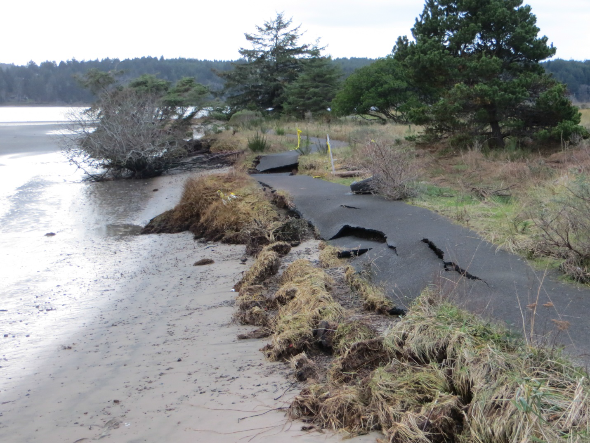
Erosion along the HMSC estuary trail. (12/21/12 by J.C. Allan)

Would making modifications to the shoreline structure help alleviate some of the erosion problems? What kinds of shoreline features would you recommend?

